

|  |
| --- |
| SQL Project  (Analyze Crime in India)  Since 2001 |
|  |
|  |



|  |
| --- |
| Introduction Crime in India is very common and happens in many different ways. Along with violent crimes (like homicide, robbery, and assault), and property crimes (like burglary, theft, motor vehicle theft, and many more), there are major problems with organized crime, the illegal drug trade, arms trafficking, corruption, and many other forms of crime.  After Analyzing this Wonderful Dataset, we discovered Various aspects of crimes happened in India from 2001.This Data Set Helps us to understand more about India. 1.What is the major reason people being kidnapped in each and every state?Answer – SQL Code SELECT KD.Area_Name,KD.Sub_Group_Name,MAX(KD.K_A_Cases_Reported) AS KD_MAX FROM  (SELECT DISTINCT Area_Name,Sub_Group_Name,K_A_Cases_Reported  FROM "39_Specific_purpose_of_kidnapping_and_abduction"  GROUP BY Area_Name,Sub_Group_Name  ORDER BY K_A_Cases_Reported DESC) AS KD  WHERE Sub_Group_Name NOT LIKE "14. TOTAL%"  group by KD.Area_Name  order by KD_MAX DESC ;  Visualization:    Conclusion: According to the dataset of kidnaping we conclude that Uttar Pradesh and Rajasthan having maximum no of Kidnap for Marriage.  **2. Offender’s relation to the rape Victim?**    Answer – SQL Code  SELECT STATE_UT, sum(CasesInWhichOffendersWereKnownToTheVictims) AS "C_O_VICTIMS",  sum("CasesInWhichOffendersWereParents/CloseFamilyMembers") AS "C_O_PARENTS/FM",  sum(CasesInWhichOffendersWereRelatives) AS "C_O_RELATIVES",  sum(CasesInWhichOffendersWereNeighbours) AS "C_O_NEIGHBOURS",  sum(CasesInWhichOffendersWereOtherKnownPersons) AS "C_O_O.Kn.PERSONS"  FROM "Offenders_relation_to_rape_victim"  GROUP BY STATE_UT  ORDER BY C_O_VICTIMS DESC; |
| Visualization: |
| Conclusion: According to the dataset of Rape we conclude that Madhya Pradesh having maximum no of Rape in India and we also conclude that every rape victim there is relation like their parents close Family members, relatives, neighbour’s and other Know Persons.  Top Five States in Rape Crimes  1.Madhya Pradesh  2. Uttar Pradesh  3. Maharashtra  4. Rajasthan  5. Chhattisgarh  **3. Juveniles** **family** **background,** **education** **and** **economic** **setup?** |

Answer – SQL Code

SELECT ED.Area_Name,ED.Sub_Group_Name,ED."Education_Above_Primary_but_below_Matric_or_Higher_Secondary" AS "Above Primary but below Matric or Higher Secondary",ED.Education_Illiterate,

ED."Education_Matric_or_Higher_Secondary_&_above",ED.Education_Upto_primary,

ES.Sub_Group_Name,ES."Economic_Set_up_Annual_Income_250001_to_50000" AS "Annual Income(25000 to 50000)",ES."Economic_Set_up_Annual_Income_upto_Rs_25000" AS "Annual Income Upto 25000",

ES."Economic_Set_up_Middle_income_from_100001_to_200000" AS "Middle Income (100000 to 200000)",ES."Economic_Set_up_Middle_income_from_50001_to_100000" AS "Middle Income (50000 to 100000)",

ES."Economic_Set_up_Upper_middle_income_from_200001_to_300000" AS "Upper Middle Income (200000 To 300000)" ,ES."Economic_Set_up_Upper_income_above_Rs_300000" AS "Upper Income Above 300000)",

FB.Sub_Group_Name,FB."Family_back_ground_Homeless" AS "Homeless",FB."Family_back_ground_Living_with_guardian" AS "Living With Guardian",FB."Family_back_ground_Living_with_parents" AS "Living With Parents"

FROM "18_01_Juveniles_arrested_Education" ED

JOIN "18_02_Juveniles_arrested_Economic_setup" ES on ED.Area_Name=ES.Area_Name and ED.Year=ES.Year

JOIN "18_03_Juveniles_arrested_Family_background" FB on ED.Area_Name=FB.Area_Name and ED.year=FB.Year

GROUP by ED.Area_Name

Order By ED."Area_Name" ASC

Visualization:

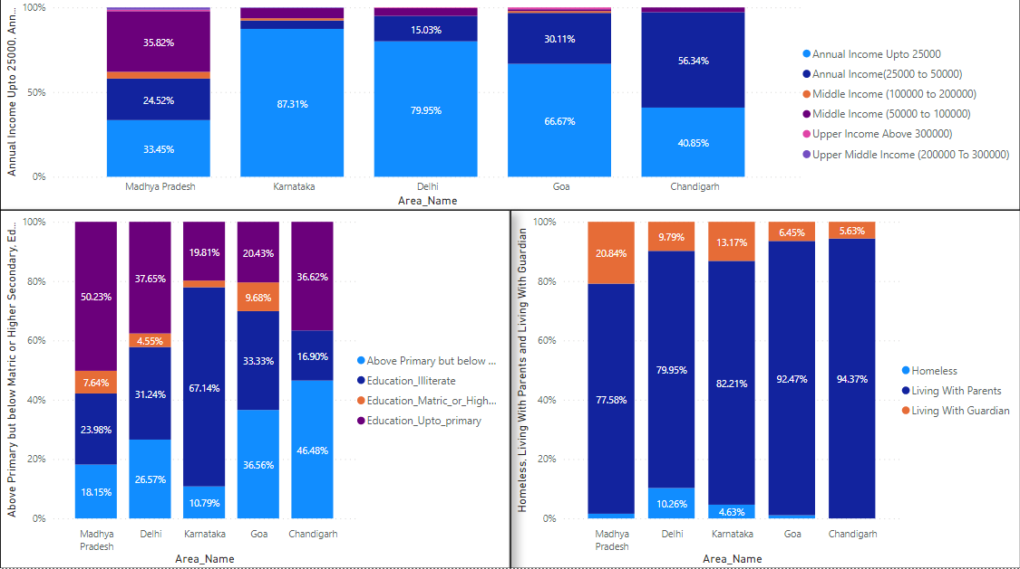

Conclusion: According to the dataset of Juveniles in India most of them are coming from Madhya Pradesh, Karnataka, Delhi, Goa, Chandigarh and maximum of them are living with parents earning income up to 25000 and not getting better education all these three reasons are highly responsible and the most common reasons for a child to go against the law is either lack of education or faults in their upbringing that is due to unhealthy socio-cultural environment resulting in the child to become physically and mentally unfit as well as an irresponsible citizen.

**4.Which** **state** **has** **more** **crime** **against** **children** **and** **women?** 

**Answer – SQL Code**

SELECT

T1.STATE_UT,T1.CRIME_AGAINST_CHILDREN,T2.CRIME_AGAINST_WOMEN FROM

(SELECT STATE_UT,SUM(TOTAL) AS “CRIME_AGAINST_CHILDREN”

FROM District_wise_crimes_committed_against_children_2001_2013

GROUP BY STATE_UT) AS T1

INNER JOIN

(SELECT STATE_UT,SUM(Rape+KidnappingandAbduction+DowryDeaths+Assaultonwomenwithintenttooutragehermodesty

+InsulttomodestyofWomen+CrueltybyHusbandorhisRelatives+ImportationofGirls) AS CRIME_AGAINST_WOMEN

FROM District_wise_crimes_committed_against_women_2001_2013

GROUP BY STATE_UT) AS T2

on T1.STATE_UT=T2.STATE_UT

ORDER BY CRIME_AGAINST_CHILDREN DESC;

**Visualization:**

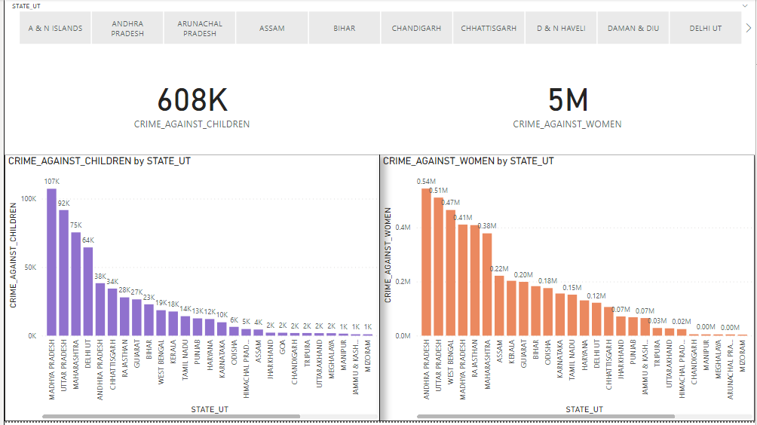

Conclusion: According to the dataset of Children and Women we conclude that Madhya Pradesh having maximum no of Crimes against Children and Andhra Pradesh having maximum number of Crimes against Women and year by year numbers are increasing. Women experience violence in numerous ways and it could be from physical or emotional abuse to sexual assault and from financial abuse to sexual harassment or trafficking and Domestic Violence.

**5.Age** **group** **wise** **murder** **victim.**

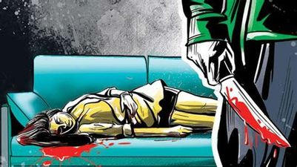

Answer – SQL Code

SELECT DISTINCT(Group_Name),

SUM(Victims_Upto_10_Yrs)AS "VIC_UPTO_10 Yrs",

SUM(Victims_Upto_10_15_Yrs) AS "VIC_UPTO_10_15 Yrs",

SUM(Victims_Upto_15_18_Yrs) AS "VIC_UPTO_15_18 Yrs",

SUM(Victims_Upto_18_30_Yrs) AS "VIC_UPTO_18_30 Yrs",

SUM(Victims_Upto_30_50_Yrs) AS "VIC_UPTO_30_50 Yrs",

SUM(Victims_Above_50_Yrs) AS "VIC-ABOVE_50 Yrs",

SUM (Victims_Total) AS "VIC_TOTAL"

FROM "32_Murder_victim_age_sex"

WHERE "Group_Name" NOT LIKE "NULL"

GROUP BY Group_Name

ORDER BY "VIC_TOTAL" DESC;

**Visualization:**

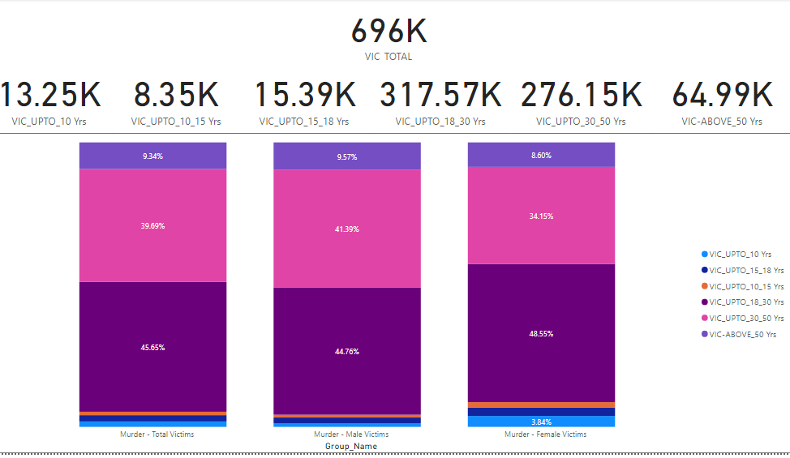

Conclusion: According to the dataset of Murder Victims we conclude that the maximum number of Murder Victims are above the age of 18Yrs and below 30Yrs and the female Victims are high compare to male victims because as you can see in the above analysis the rate of crimes against women are increasing at a peak level.

**6.** **Crime** **by** **place** **of** **occurrence**.



**Answer – SQL Code**

SELECT C1."STATE_UT",

SUM(C1.TOTAL_Burglary+"C2.TOTAL-Burglary")AS "CRIME_BY_BURGLARY",

SUM(C1.TOTAL_Dacoity+"C2.TOTAL-Dacoity")AS "CRIME_BY_DACOITY",

SUM(C1.TOTAL_Robbery+"C2.TOTAL-Robbery")AS "CRIME_BY_ROBBERY",

SUM(C1.TOTAL_Theft+"C2.TOTAL-Theft")AS "CRIME_BY_THEFT"

FROM Crime_by_place_of_occurrence_2001_2013 AS C1

LEFT JOIN Crime_by_place_of_occurrence_2014 AS C2

ON "C1.STATE/UT" = "C2.STATE/UT"

GROUP BY C1.STATE_UT

**Visualization:**

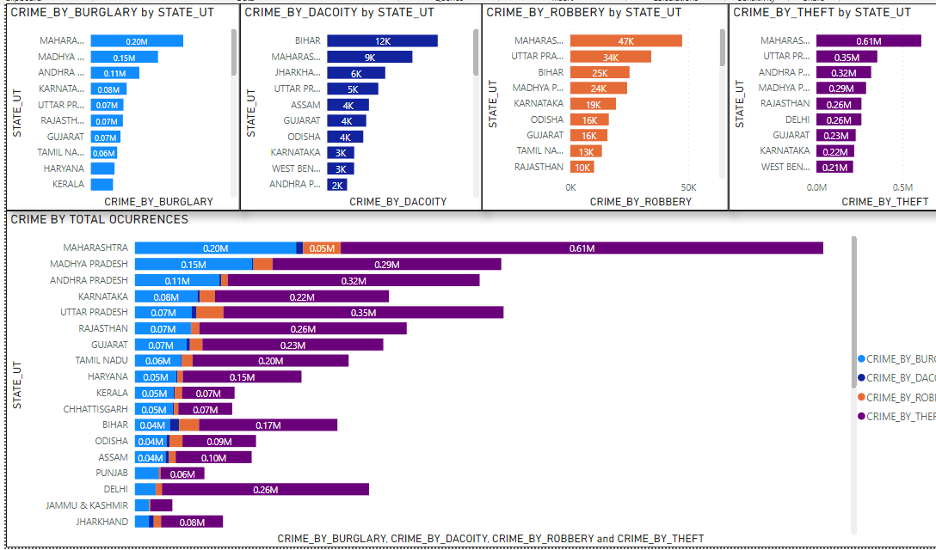

Conclusion: According to the dataset of Crime by Occurrences we conclude that Maharashtra has maximum number of crimes by occurrences and most of the crimes are by theft which is around “0.61 M”, and there are also certain crime like Burglary and Robbery in the state. We also find that maximum Dacoity are taking place in Bihar.

**7.Anti**-**corruption** **cases** **vs** **arrests.**

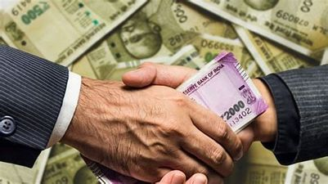

**Answer – SQL Code**

SELECT T1.Area_Name,T1.Year,

T1.AC02_No_of_cases_registered_during_the_year as "CASE_REG_Yr",

T2.ACA02_No_of_persons_arrested_during_the_year AS "ARRESTED_PERSONS"

FROM "23_Anti_corruprion_cases" AS "T1"

JOIN "24_Anti_corruption_arrests" AS "T2"

ON T1.Area_Name = T2.Area_Name

WHERE T1.Area_Name NOT LIKE "NULL"

GROUP BY T1.Area_Name,T1.Year

**Visualization:**

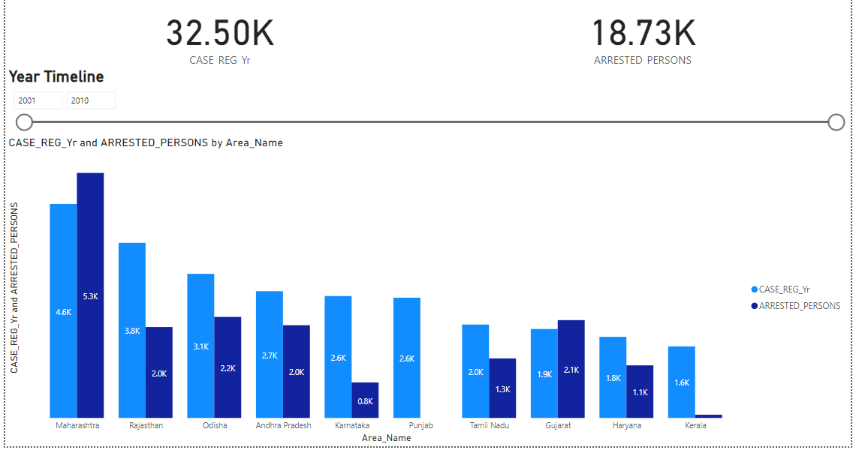

Conclusion: Corruption in India is an issue which affects the economy of central, state and local government agencies in many ways. According to the dataset of Corruption we conclude that Maharashtra and Rajasthan have maximum number of Cases registered against Corruption and Punjab is the only state which has zero Arrest corresponding to the registered cases.

**8.Which** **state** **has** **a greater** **number** **of** **complaints** **against** **police?**



**Answer – SQL Code**

SELECT Area_Name,MAX( "CPA_-_Cases_Registered" ) AS "C.AGAINST_POLICE"

FROM "25_Complaints_against_police"

WHERE "CPA_-_Cases_Registered" NOT LIKE "NULL"

group by Area_Name

ORDER BY "C.AGAINST_POLICE" DESC;

Visualization:

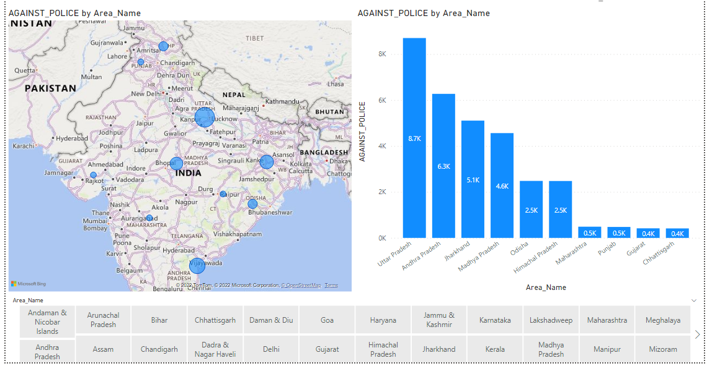

Conclusion: According to the dataset of Complaints against Police we conclude that Uttar Pradesh, Andhra Pradesh, Jharkhand, Madhya Pradesh, Odisha having maximum number of cases registered against Police Officials.

**9.Which** **state** **is** **the** **safest** **for** **foreigners?**

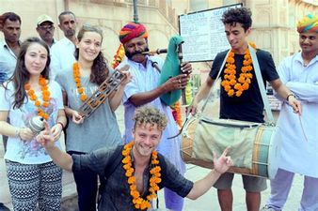

**Answer – SQL Code**

SELECT crime_2012.STATE_UT,STATE_POPULATION.Population,(("Total Crimes"/STATE_POPULATION.Population)*100) AS "Crime By Percentage",

SUM(crime_2012.TOTALIPCCRIMES+crime_2013.TOTALIPCCRIMES+crime_2014.TotalCognizableIPCcrimes) AS "TOTAL CRIMES"

FROM crime_2012 JOIN crime_2013

ON crime_2012.STATE_UT = crime_2013.STATE_UT

JOIN crime_2014

ON crime_2012.STATE_UT = crime_2014.STATE_UT

JOIN STATE_POPULATION

ON crime_2012.STATE_UT = STATE_POPULATION.AREA_NAME

GROUP BY crime_2012.STATE_UT

ORDER BY "TOTAL CRIMES" ASC;

Visualization:

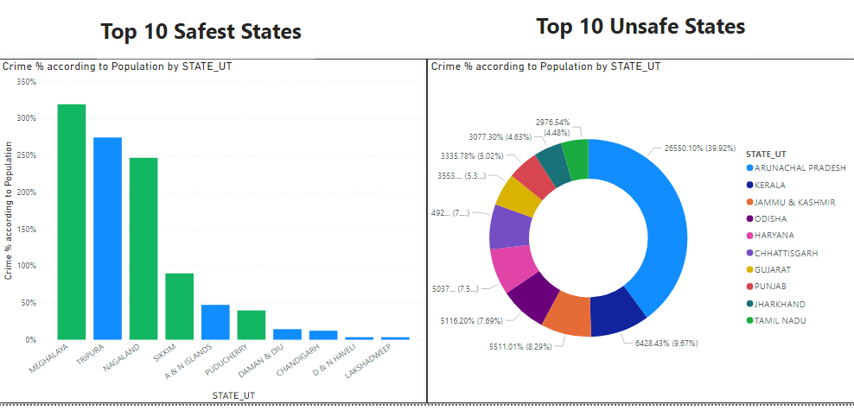  
**Conclusion:** **According to the dataset of Crime and Population we conclude and analyzed that Meghalaya, Tripura, Nagaland, Sikkim are the four Safest States in India for Foreigners and Arunachal Pradesh have the highest percentage of Crimes in India followed by Kerala.**